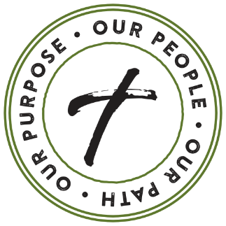

WEEKEND 1 – BULLETIN ANNOUNCEMENT

We begin our annual stewardship initiative this weekend. Our Path Forward – 2021 and Beyond is a fitting theme as we recover from a challenging year and look toward the future. I do not enter into stewardship lightly. I know there may be those of you who have been impacted in ways I am not aware. If our parish can assist, please reach out.

As in years past, to continue the outreach and engagement our community is known for I must ask parish members, THAT ARE ABLE, to prayerfully reflect on their annual offertory gifts and move forward on the path of your personal stewardship journey.

This is a necessary opportunity for us all to support our parish ministries and mission. I’m requesting for each one of us to take an active role in prayerfully practicing the principle of stewardship; giving back a portion of our blessings to God. If you are not able to do so, please pray for the success of our community and consider giving back gifts of your time and talent to one of our many valued ministries.

We will be holding our Stewardship Commitment Weekend on (Insert Commitment Weekend Date). In the meantime, please prayerfully consider how you will participate.

We have mailed a prayer postcard with a QR code link to the Our Path Forward web page www.opfaob.com where you may find more information, support our parish through offertory contributions and even support our parish endowment fund.

